# Django Templates

To load an HTML page using Django, you typically use Django's views and templates system.

1)Set Environment

venv/Scripts/activate

2)Install Django

ensure you have Django installed.

pip install django

3)Create a new Django project using the following command:

django-admin startproject myproject

4)Create a new Django appusing the following command:

python manage.py startapp myapp

5)Add app name into settings.py INSTALLED_APP

6)Create a Template HTML File:

Inside the myapp directory, create a new directory called templates. Inside the templates directory, create an HTML file. For example, let's create a file called

index.html:

myproject/

├── myapp/

│ ├── templates/

│ │ └── index.html

Otherwise

7)place your templates directory in the root folder of your Django project and update the TEMPLATES setting in settings.py accordingly, you can follow these steps:

Create a Templates Directory in the Root Folder:

First, create a directory named templates in the root folder of your Django project (myproject). Place your HTML templates inside this directory.

myproject/

├── myapp/

│ └── ...

├── templates/

│ └── index.html

├── manage.py

└── myproject/

├── __init__.py

├── settings.py

└── urls.py

8)Update the TEMPLATES Setting in settings.py:

Open the settings.py file in the myproject directory, and update the TEMPLATES setting to specify the location of the templates directory:

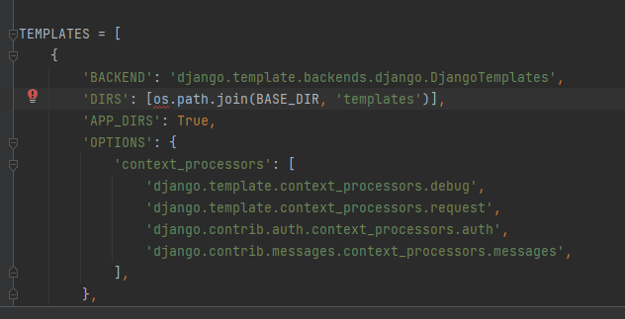

9)Here's an example index.html file:

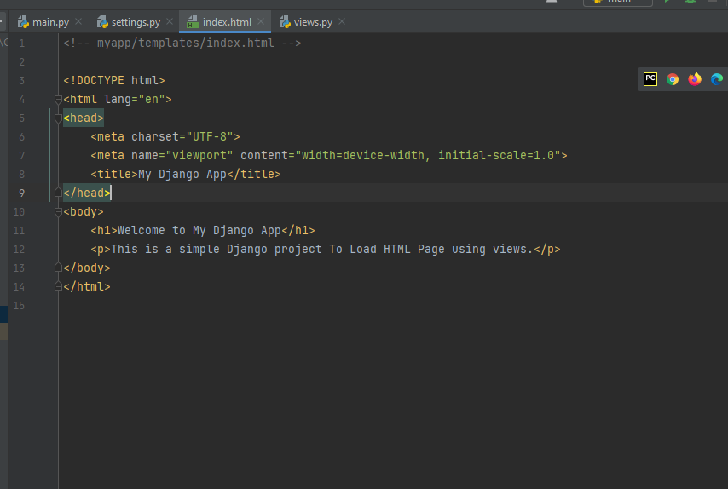

10)Define a View to Render the Template:

In the views.py file of your app (myapp/views.py), define a view function to render the template:

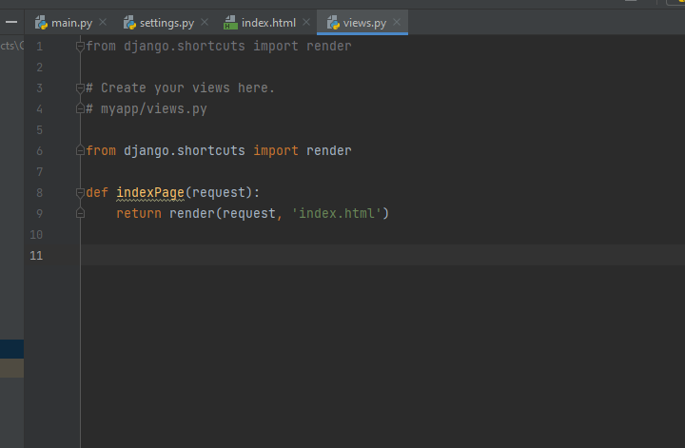

11)Map the View to a URL:

In the urls.py file of your app (myapp/urls.py), map the view function to a URL pattern:

12)Map the View to a URL:

In the urls.py file of your app (myapp/urls.py), map the view function to a URL pattern:

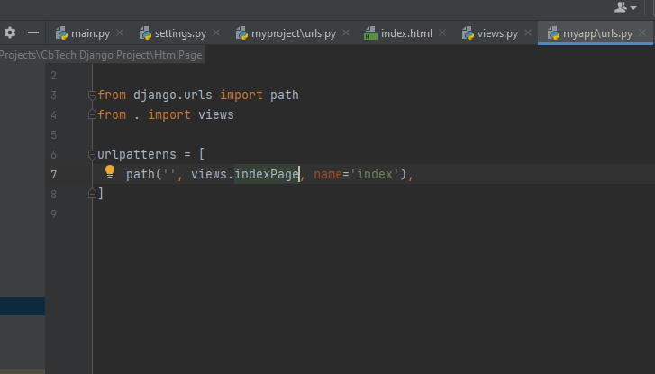

13)Include the App's URLs in the Project's URLs:

In the urls.py file of your project (myproject/urls.py), include the URLs of your app:

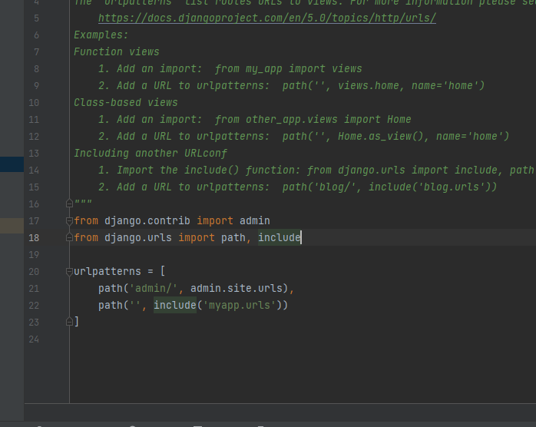

14)

Run the Development Server:

Start the Django development server:

python manage.py runserver

18)Access the HTML Page:

Open a web browser and navigate to http://127.0.0.1:8000/. You should see the HTML page rendered by Django.

